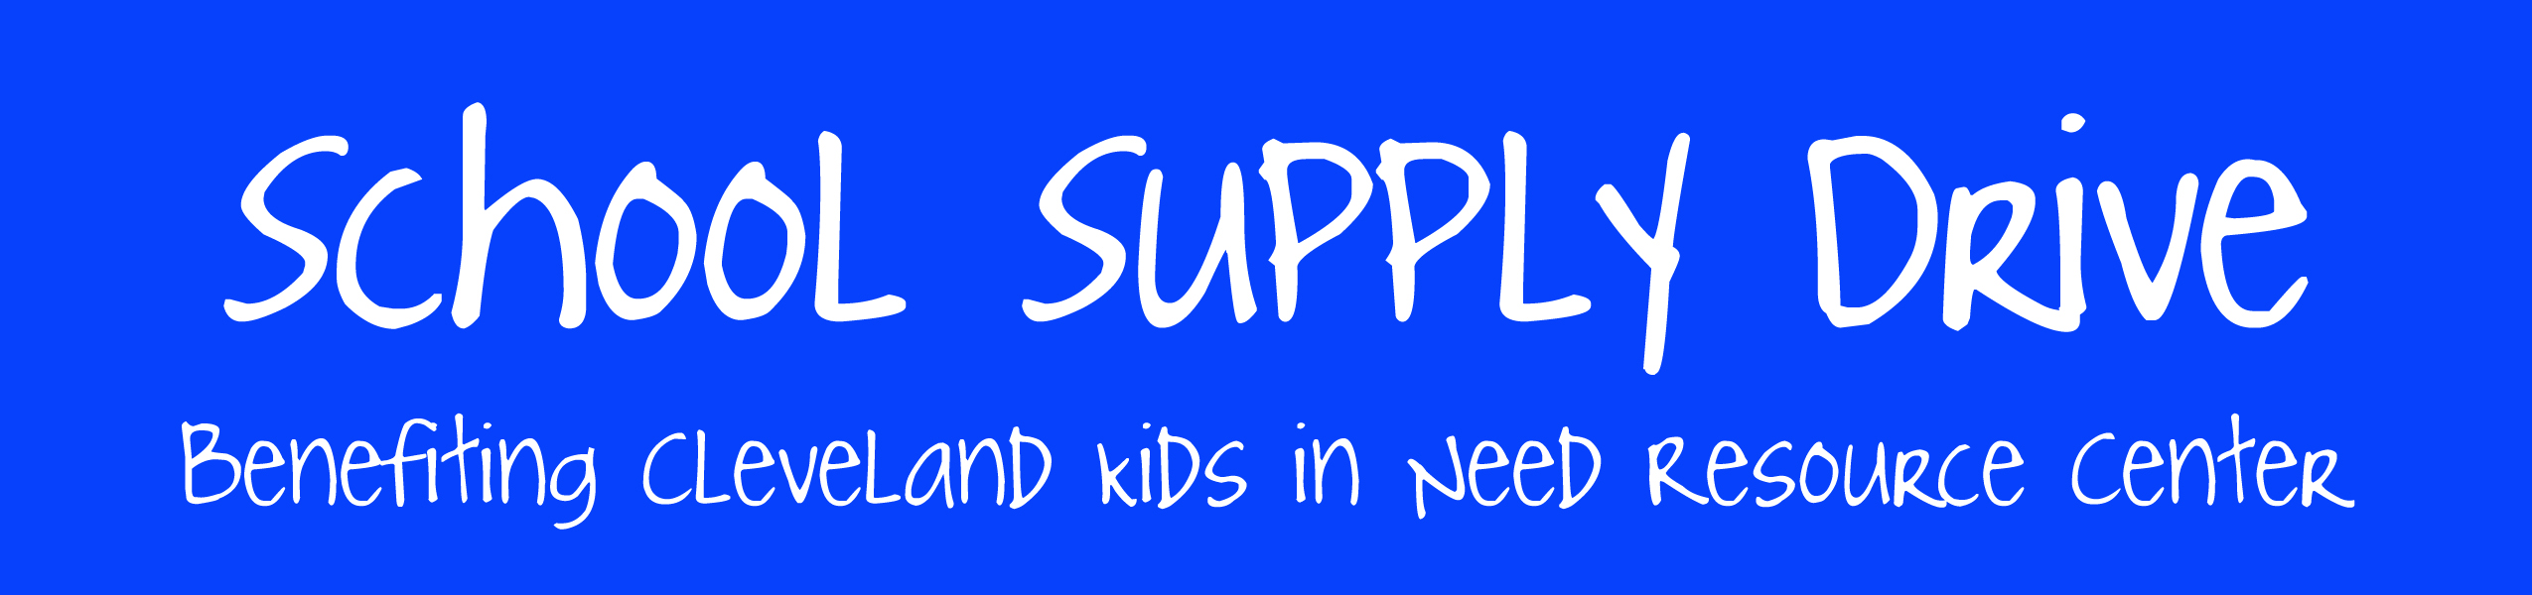

[Dates]

Pens

Markers

Colored pencils

Crayons

Construction paper

Copy paper

Filler paper

Pencils

**Most needed supplies include:**

Help [our organization] fill the backpacks of the most disadvantaged students across North East Ohio.